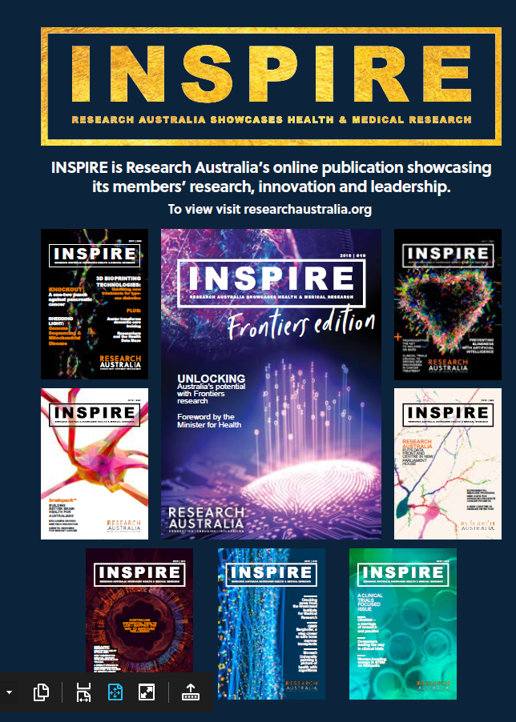
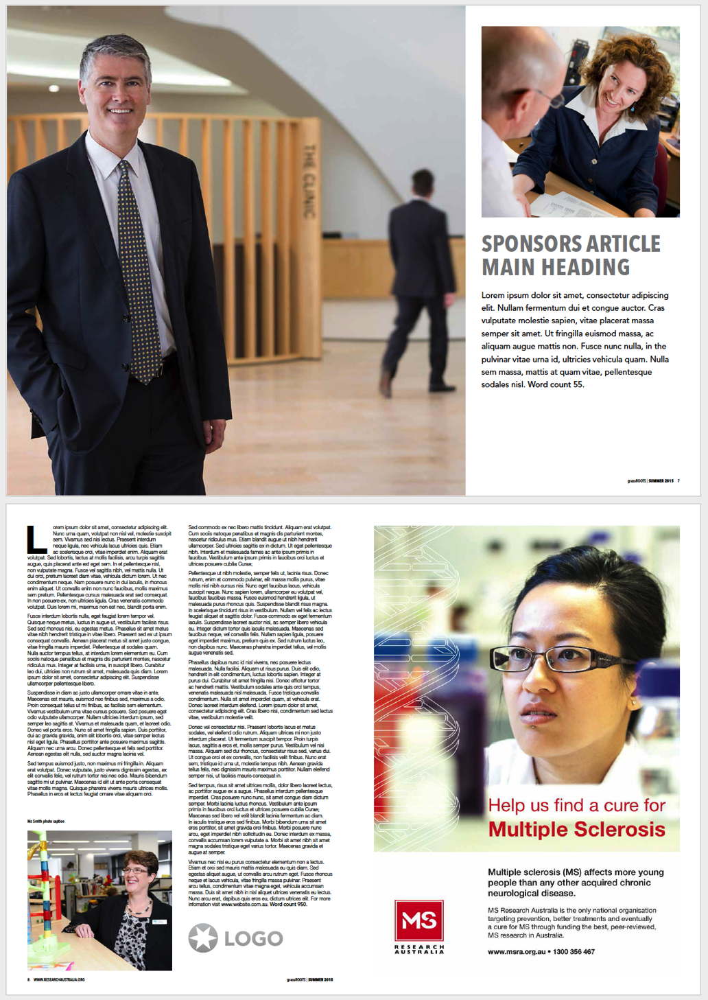
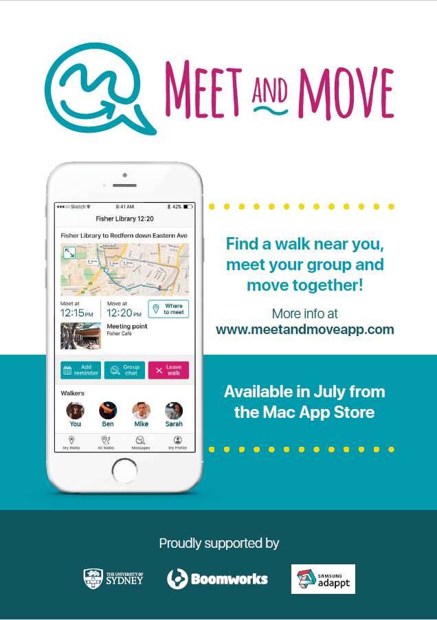
MEDIA PACK
What is our reach?

Publication
8,000+ readership across a range of distribution channels
Publication is also supplied to all contributors and is shared more broadly with their stakeholders internally and externally. Issues are read across 10 countries around the world

Social Media
Each Issue is regularly posted through all Research Australia social media channels.
Facebook: 2,973 + followers | Twitter: 8,722 + followers
Follower interests 91% Science News, 83% Business News, 130,000+ impressions in 3 months 350+ click throughs per month

Website
Research Australia Website
70,000+ visits in the last 12 months
32% new visitors | 68% returning visitors

Members: Individuals from Universities, Medical Research Institutes, Consumer Interest Groups, Large Corporates, H&MR related Associations, Foundations, Pharmaceutical, Biotech and Medical Device Companies, Government Agencies, State & Federal Politicians and Ministers, General Public.
Open rate: 115% of the industry average

ISSU online publication reader
235,842 impressions since 2014 with four issues publishes each year. Each issue has over 1000 readers and 3,000 impressions and the average time spent on each is over 7 minutes.

Our 150 members organisations share the publication through their internal channels and external networks.

INSPIRE is Research Australia’s member magazine which showcases the best Australian health and medical research projects. INSPIRE informs and inspires the community and the sector showcasing the breadth, scope and quality of the research being carried out in Australia. INSPIRE raises the profile of Australian health and medical research and promotes our members to the broader public.

INSPIRE is a professionally designed and edited quarterly e-magazine that allows our members to speak directly to the Australian public and ensure their valuable work, either raising funds, awareness or conducting research is known and valued. INSPIRE provides the public with an inspiring, engaging and easily readable resource with which to stay informed about cutting edge research and discovery into disease areas that impact their lives.

Professional and nonprofessional 25 – 80 year old males and females who are passionate about health, and understand the importance of research in ensuring health outcomes, many of which donate to health & medical research regularly.
Who is reading INSPIRE?
What is INSPIRE?
Platform | Inclusions
Publication | 4 pages / 2 double page spreads, including: Opening spread with large images, headings & subheadings for maximum impact, full page article at least 950 words including logo and website URL + full page advertisement.  Highlighted article mention on Contents Page.
Website | Logo & “sponsored by” on the INSPIRE page of the Research Australia website
Distribution | Logo & “sponsored by” on the email that goes to the entire Research Australia database announcing the release of the new issue
Social Media | Headline & excerpt from article, including image posted on all Research Australia social media linking to the magazine on ISSU and relevant sponsors social media
INVESTMENT | $2,500

Sponsor an edition of INSPIRE for maximum exposure.

Advertorial

INSPIRE’s reach continues to growth with our increase in membership, increase in social media following and the breadth of our community impact.
Research Australia now offers various advertorial and advertising options to further help promote our members key messaging and increase the profile of Australian health and medical research nationally and internationally.

Advertorial & Advertising
ADVERTORIAL
Advertise in INSPIRE magazine and promote your key messaging, events, campaigns or just increase your profile. We offer 3 sizes and the specifications are below

Full page:
Artwork: 297mm (h) x 210mm (w)
5mm bleed

1/2 page
Artwork: 131mm (h) x 180mm (w)
no bleed required

1/3 page
Artwork: 85mm (h) x 180mm (w)
no bleed required

1/4 page
Artwork: 63mm (h) x 180mm (w)
no bleed required

Platform | Inclusions
Publication | Advertisements do allow for hyperlinking from the publication back to your business.
Social Media | Copy provided by Advertiser, promoting their organisation / event / campaign etc and web URL posted on all Research Australia social media along with advert image once during publication cycle.
INVESTMENT | Full Page $2,000  Half Page $1,000  Third Page $750

Advertising Specs & Costs
Full Page Ad Example
Issue | Abstracts Deadline | Article & Advertising  Deadline | Publish
Focus: Preventative healthcare
Autumn  Issue 15 | 7 February | 14 February | March
Focus: Health & medical research for children and youth
Winter  Issue 16 | 9 April | 30 April | May
Focus: Innovation in data & technology in health & medical research
Spring  Issue 17 | 19 July | 16 August | August
Focus: Translational research & 2020 Awards
Summer  Issue 18 | 9 October | 30 October | November
More information
To discuss how Research Australia can promote your organisation, event or campaign or for more information on the above packages, please contact:

Sally Shepherd
Partnerships and Marketing Manager
Research Australia
(02) 9295 8545
sally.shepherd@researchaustralia.org
www.researchaustralia.org
Publishing Deadlines 2020

