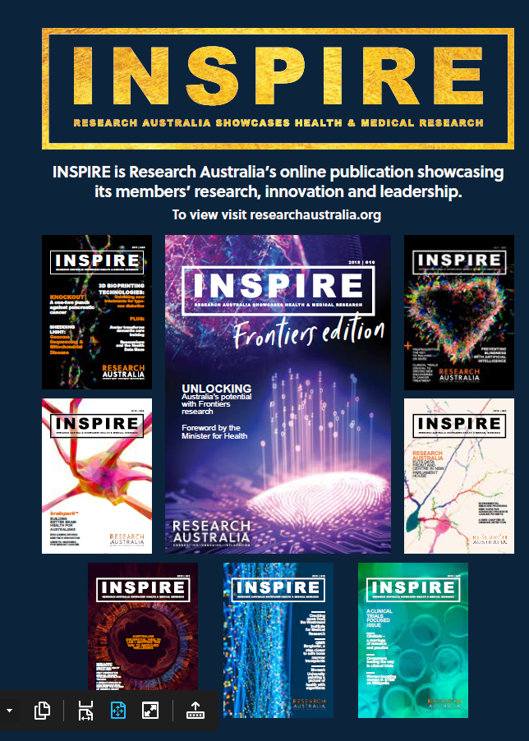

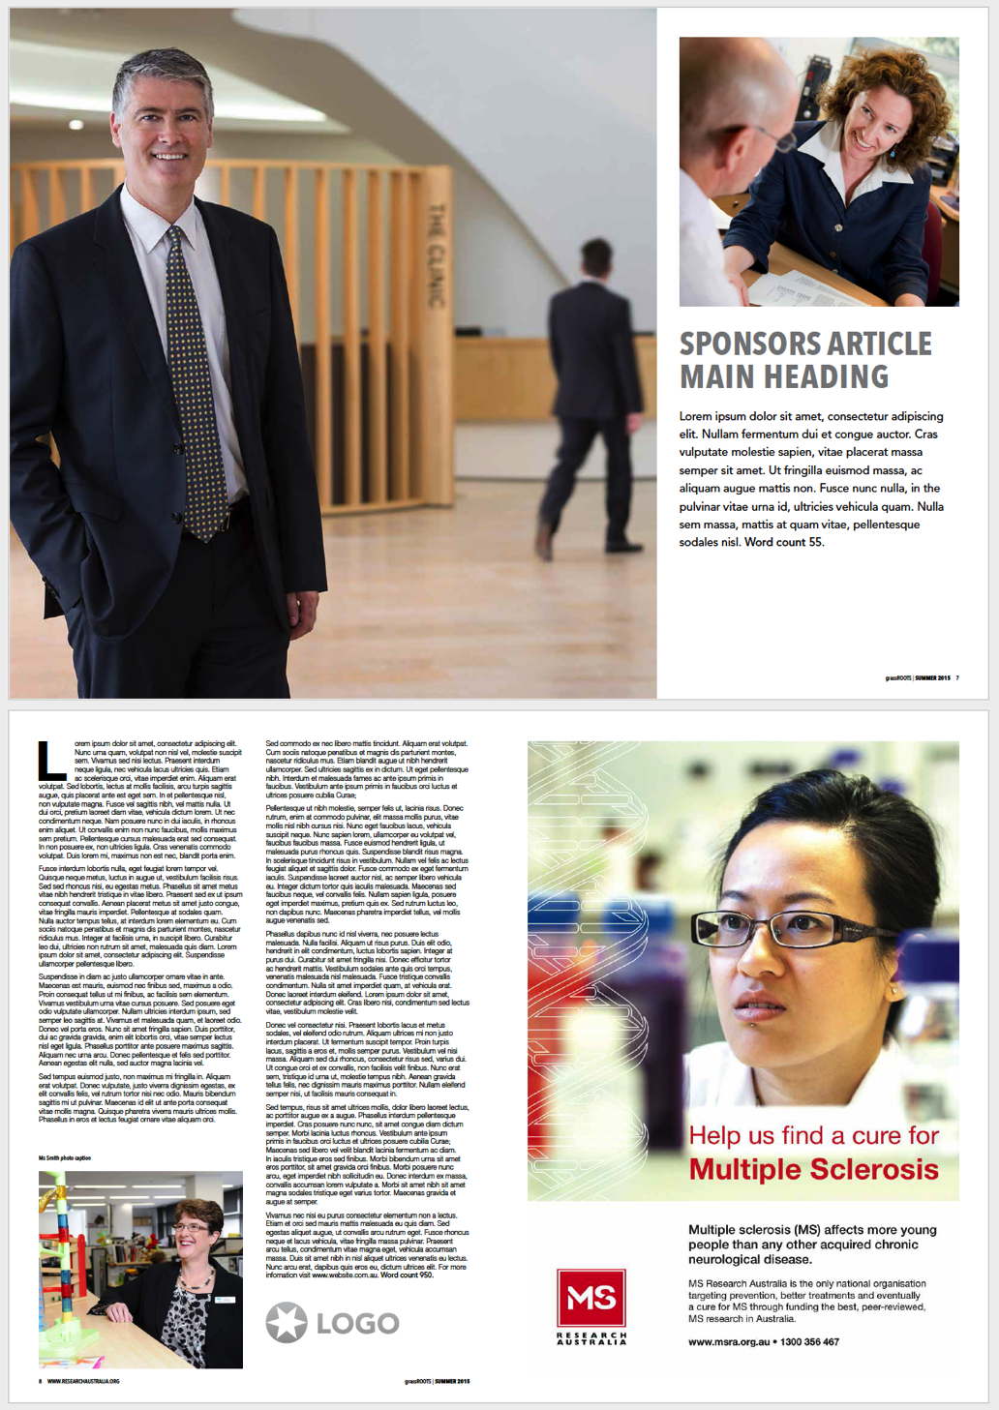

MEDIA PACK

DEMOGRAPHICS

Professional and nonprofessional 25 – 80-year-old males and females who work in or have an interest in health and understand the importance of research in ensuring health outcomes.

Each issue has a focus area from across the pipeline to group the contributors to a common theme. This allows for targeting specific organisations for editorial, advertorials and advertising.

INSPIRE is Research Australia’s signature publication which showcases our members research, thought leadership, innovation, technology and philanthropy. It informs and inspires the entire health and medical research sector and highlights the breadth, scope and quality of the research being carried out in Australia.

The publication allows us to raise the profile of Australian health and medical research and promotes our members to the broader sector and Australian community. It is also a powerful channel for organisations offering services to the sector to increase their brand, products and profile through advertising and advertorials.

INSPIRE is a professionally produced quarterly e-magazine which allows our member organisations to speak directly to the sector and public. Each issue features a variety of articles around groundbreaking innovations in research, advances in technology in health, case studies of research being funded by philanthropic organisations and collaborative efforts with national and international organisations.

INSPIRE provides a broad readership with an engaging and easily readable resource with which to stay informed about cutting edge research and discovery into health areas that impact their lives.

DISTRIBUTION

Our Membership

Each issue is distributed to the Research Australia membership which reaches around 1500 contacts from across 140 organisations nationally and internationally. Our member organisations then re-distribute through their internal and external networks.

Contributors featured in an issue often feature the publication in their newsletters, website and other key marketing channels.

The Issuu platform provides analytics and advise INPSIRE is consistently read across 10 countries around the world and the average reading time is around 7 minutes which is extremely high compared with industry standard. The open rate of our EDM’s is **115%** of the industry average.

What is INSPIRE?

Website

**Research Australia Website**

**80,000+** visits in the last 12 months

**32%** new visitors | **68%** returning visitors

**Members:** Individuals from Universities, Medical Research Institutes, Consumer Interest Groups, Large Corporates, H&MR related Associations, Foundations, Pharmaceutical, Biotech and Medical Device Companies, Government Agencies, State & Federal Politicians and Ministers, General Public.

**ISSUU online publication reader**

Each issue has between 1000 -2000 readers and between 3,000-5,000 impressions.

Most importantly and the average time spent on each is between 6-8 minutes.

**Recent Issues**

Issue 19 was published in May 2021 has had **1,269 reads, 2699** impressions with an impressive average reading time of 8.02mins.

E Signatures

The Research Australia team features the INSPIRE banner of the latest issue on their signatures reaching the hundreds of email recipients sent by the team over a period of 2-3 months until the next issue is published.

Social Media

Each Issue is promoted through all Research Australia social media channels with posts to encourage further distribution. The banner and link of each issue is featured on the social media platform furthering exposure with click throughs from all posts for a 2-3 month period.

Twitter: **9,999** followers

Facebook: **3,275** followers

Linkedin: **795** followers

INSPIRE’s reach continues to growth with our increase in membership, increase in social media following and the breadth of our community impact. Research Australia now offers various advertorial and advertising options to further help promote our members key messaging and increase the profile of Australian health and medical research nationally and internationally.

ADVERTORIAL

**ADVERTISEMENTS**

Advertise in INSPIRE magazine and promote your key messaging, events, campaigns or just increase your profile. We offer 4 sizes and the specifications are below

**Full page = $2000 +gst**Artwork: 297mm (h) x 210mm (w)  
5mm bleed

**1/2 page = $1000 +gst**

Artwork: 131mm (h) x 180mm (w)  
no bleed required

**1/3 page = $750 +gst**

Artwork: 85mm (h) x 180mm (w)  
no bleed required

**1/4 page = $500 +gst**

Artwork: 63mm (h) x 180mm (w)  
no bleed required

**ADVERTORIAL**

**Double page spread = $25,000 +gst**

PROMOTIONAL PACKAGES

We do offer bespoke packages to meet your specific business objectives. Please call us to discuss how best to promote your organisation.

SPECIFICATIONS & COSTS

Full Page Ad Example

Publishing Deadlines 2021

**ENQUIRIES**

To discuss how Research Australia can promote your organisation, event or campaign or for more information please contact us as per below. We do offer bespoke packages to meet your specific business objectives.

Research Australia

Phone: (02) 92958545

Email: [admin@researchaustralia.org](mailto:admin@researchaustralia.org)

[www.researchaustralia.org](http://www.researchaustralia.org)

|  |  |  |  |
| --- | --- | --- | --- |
| **2021** | **ABSTRACTS DUE** | **FINAL ARTICLE DEADLINE** | **PUBLISH MONTH** |
| **Autumn *Issue 19*** | 5 February | 26 February | **April** |
| **Focus** | **The transformative power of data and technology in HMR** | | |
| **Winter   *Issue 20*** | 14 May | 4 June | **July** |
| **Focus** | **National & International Collaboration – the key to HMR research progression** | | |
| **Spring *Issue 21*** | 9 July | 30 July | **Aug/Sept** |
| **Focus** | **Keeping the consumer in focus in HMR (Part 1)** | | |
| **Summer *Issue 22*** | 8 October | 30 October | **Oct/Nov** |
| **THEME** | **Keeping the consumer in focus in HMR (Part II)** | | |

More information