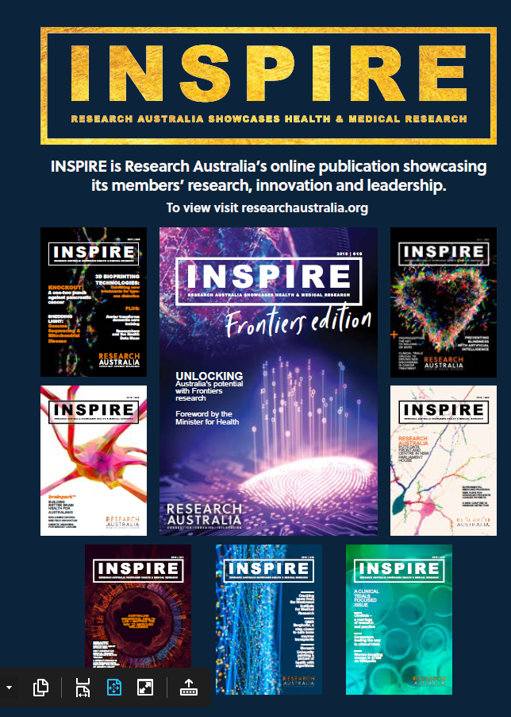

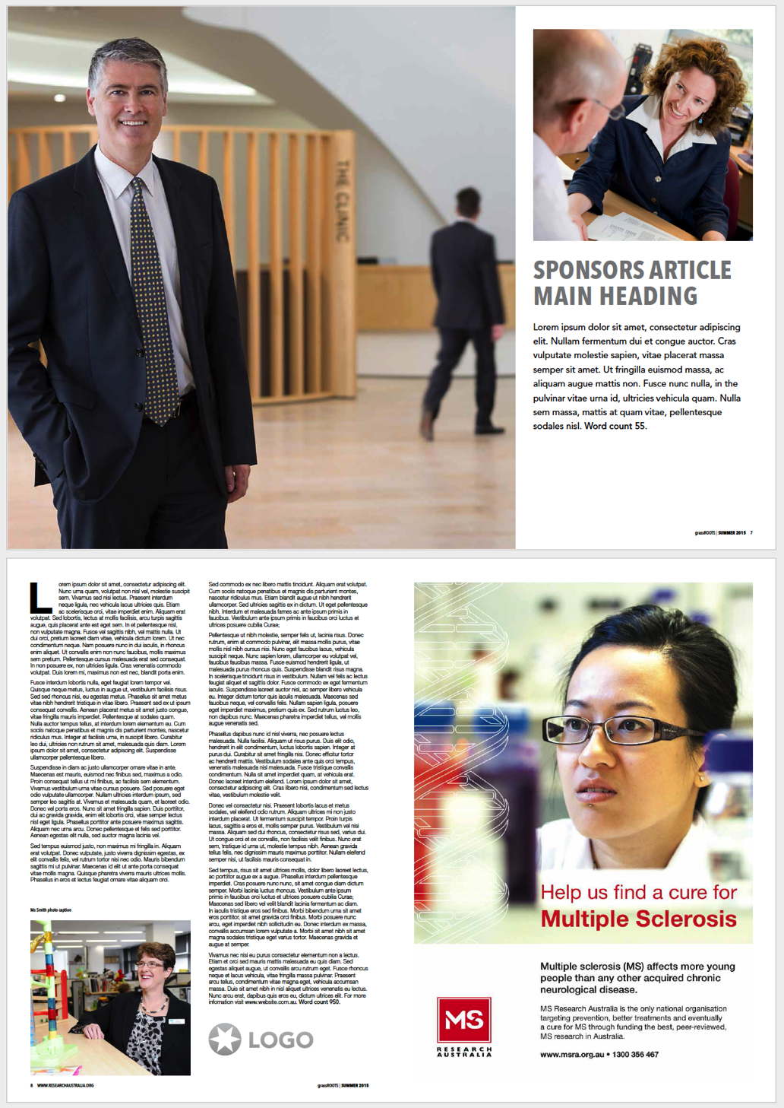

MEDIA PACK

What is our reach?

Publication

Each issue is distributed to the Research Australia membership (around 1500 contacts). The member organisations then forward the links or pdf version through their internal and external networks. Naturally if they have an article in the Issuu they are more likely to showcase the issue through their channels.

The Issuu platform provides analytics and advise INPSIRE is consistently read across 10 countries around the world and the average reading time is around 7 minutes which is extremely high compared with industry standard. The open rate of our EDM’s is **115%** of the industry average.

Social Media

Each Issue is promoted through all Research Australia social media channels encouraging further distribution. Facebook: **3,275** followers Twitter: **9,999** followers Linkedin: **795** followers (4.6% click through rate)

Website

**Research Australia Website**

**80,000+** visits in the last 12 months

**32%** new visitors | **68%** returning visitors

**Members:** Individuals from Universities, Medical Research Institutes, Consumer Interest Groups, Large Corporates, H&MR related Associations, Foundations, Pharmaceutical, Biotech and Medical Device Companies, Government Agencies, State & Federal Politicians and Ministers, General Public.

**ISSUU online publication reader**

Each issue has between 1000 -2000 readers and between 3,000-5,000 impressions. Most importantly and the average time spent on each is between 6-8 minutes. Issue 19 has had **1,269 reads, 2699** impressions with an average reading time of 8.02mins.

INSPIRE is Research Australia’s signature publication which showcases the best Australian health and medical research projects. INSPIRE informs and inspires the community and the sector showcasing the breadth, scope and quality of the research being carried out in Australia. INSPIRE raises the profile of Australian health and medical research and promotes our members to the broader sector and Australian community.

INSPIRE is a professionally produced quarterly e-magazine that allows our members to speak directly to the sector and public. It is a powerful channel to showcase their ground breaking innovations in research, fundraising or to profile leaders in their organisations. INSPIRE provides a broad readership with an inspiring, engaging and easily readable resource with which to stay informed about cutting edge research and discovery into health areas that impact their lives.

Advertisers wanting to reach our niche audience through the membership and their networks benefit from a demographic that expands the entire health and medical research pipeline.

Who is reading INSPIRE?

Professional and nonprofessional 25 – 80-year-old males and females who work in or have an interest in health and understand the importance of research in ensuring health outcomes. Each issue has a focus area from across the pipeline to group the contributors to a common theme. This allows for targeting specific organisations for editorial, advertorials and advertising.

What is INSPIRE?

|  |  |
| --- | --- |
| Platform | Inclusions |
| Publication | Double page spread, including: Opening spread with large images, headings & subheadings for maximum impact, full page article around 800 words including logo and website URL. Avertorial is included on the Contents Page. |
| Website | INSPIRE is promoted on a dedicate landing page |
| Distribution | An email is sent to the entire Research Australia database announcing the release of the new issue.  A banner of the current issue is places on Research Australia’s team esignatures to further the reach. |
| Social Media | Banners are designed for each issue and contributors listed/tagged where possible in posts/promotions. A bespoke post is designed linking to the advertorial. |
| INVESTMENT | **$2,500** |

Advertorial

INSPIRE’s reach continues to growth with our increase in membership, increase in social media following and the breadth of our community impact. Research Australia now offers various advertorial and advertising options to further help promote our members key messaging and increase the profile of Australian health and medical research nationally and internationally.

Advertorial & Advertising

ADVERTORIAL

|  |  |
| --- | --- |
| Platform | Inclusions |
| Publication | Advertisements do allow for hyperlinking from the publication back to your business. |
| Social Media | Copy provided by Advertiser, promoting their organisation / event / campaign etc and web URL posted on all Research Australia social media along with advert image once during publication cycle. |
| INVESTMENT | **Full Page $2,000**  **Half Page $1,000**  **Third Page $ 750** |
|  |  |

Advertise in INSPIRE magazine and promote your key messaging, events, campaigns or just increase your profile. We offer 3 sizes and the specifications are below

**Full page:**Artwork: 297mm (h) x 210mm (w)  
5mm bleed

**1/2 page**

Artwork: 131mm (h) x 180mm (w)  
no bleed required

**1/3 page**

Artwork: 85mm (h) x 180mm (w)  
no bleed required

**1/4 page**

Artwork: 63mm (h) x 180mm (w)  
no bleed required

Advertising Specs & Costs

Full Page Ad Example

Publishing Deadlines 2021

|  |  |  |  |
| --- | --- | --- | --- |
| **2021** | **ABSTRACTS DUE** | **FINAL ARTICLE DEADLINE** | **PUBLISH MONTH** |
| **Autumn *Issue 19*** | 5 February | 26 February | **April** |
| **Focus** | **The transformative power of data and technology in HMR** | | |
| **Winter   *Issue 20*** | 14 May | 4 June | **July** |
| **Focus** | **National & International Collaboration – the key to HMR research progression** | | |
| **Spring *Issue 21*** | 9 July | 30 July | **Aug/Sept** |
| **Focus** | **Keeping the consumer in focus in HMR (Part 1)** | | |
| **Summer *Issue 22*** | 8 October | 30 October | **Oct/Nov** |
| **THEME** | **Keeping the consumer in focus in HMR (Part II)** | | |

To discuss how Research Australia can promote your organisation, event or campaign or for more information on the above packages, please contact:

**Sally Shepherd**

Partnerships and Marketing Manager

Research Australia

0413 77 22 85

[sally.shepherd@researchaustralia.org](mailto:sally.shepherd@researchaustralia.org)

[www.researchaustralia.org](http://www.researchaustralia.org)

More information