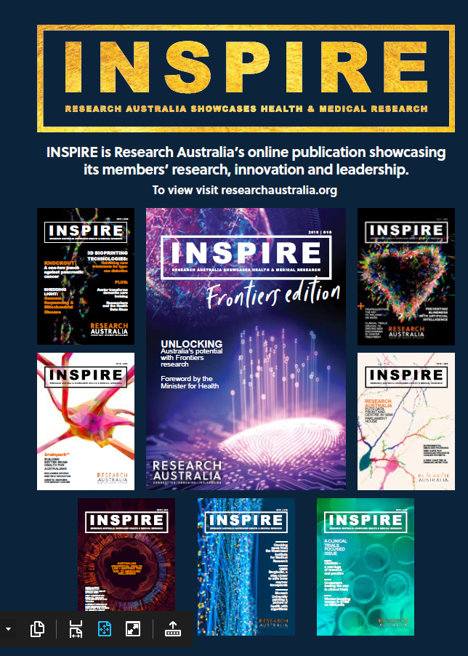
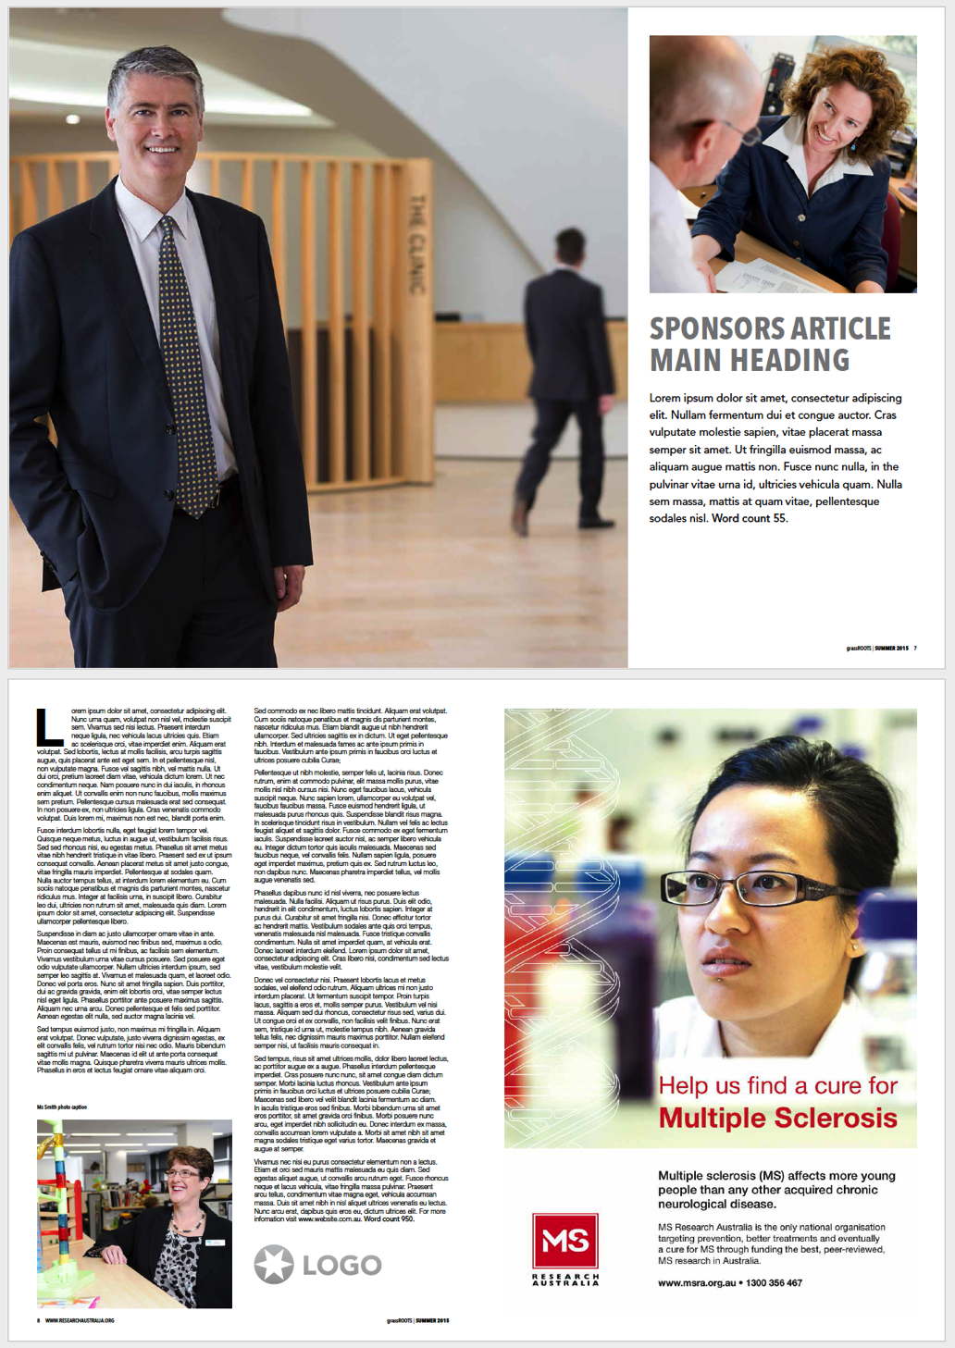
MEDIA PACK

DEMOGRAPHICS
Professional and nonprofessional 25 – 80-year-old males and females who work in or have an interest in health and understand the importance of research in ensuring health outcomes.

Each issue has a focus area from across the pipeline to group the contributors to a common theme. This allows for targeting specific organisations for editorial, advertorials and advertising.

INSPIRE is Research Australia’s signature publication which showcases our members research, thought leadership, innovation, technology and philanthropy. It informs and inspires the entire health and medical research sector and highlights the breadth, scope and quality of the research being carried out in Australia.

The publication allows us to raise the profile of Australian health and medical research and promotes our members to the broader sector and Australian community. It is also a powerful channel for organisations offering services to the sector to increase their brand, products and profile through advertising and advertorials.

INSPIRE is a professionally produced quarterly e-magazine which allows our member organisations to speak directly to the sector and public. Each issue features a variety of articles around groundbreaking innovations in research, advances in technology in health, case studies of research being funded by philanthropic organisations and collaborative efforts with national and international organisations.

INSPIRE provides a broad readership with an engaging and easily readable resource with which to stay informed about cutting edge research and discovery into health areas that impact their lives.

DISTRIBUTION
Our Membership
Each issue is distributed to the Research Australia membership which reaches around 1500 contacts from across 140 organisations nationally and internationally. Our member organisations then re-distribute through their internal and external networks.

Contributors featured in an issue often feature the publication in their newsletters, website and other key marketing channels.

The Issuu platform provides analytics and advise INPSIRE is consistently read across 10 countries around the world and the average reading time is around 7 minutes which is extremely high compared with industry standard. The open rate of our EDM’s is 115% of the industry average.

What is INSPIRE?
Website
Research Australia Website

The website attracts around 1000 visits each week with 32% being new visitors and 68% returning visitors. Content is updated regularly and social media links to the website daily.

Visits per day:
- Average 2021 148 visits per day
- Average in July 2021 201 visits
- Average 2020 182

Visits per month:
- For the month of July 2021 4,554 (organic)
- 2021 Average views per month in 2021 4,316
- 2020 Average visits per month in 2020 5,556.

Most popular fixed pages (last 90 days – April 24 to July 2021)
- Home page 3,327 views
- Funding announcements 1,510 views
- INSPIRE 735 views
- All members list 510 views

Members: Individuals from Universities, Medical Research Institutes, Consumer Interest Groups, Large Corporates, H&MR related Associations, Foundations, Pharmaceutical, Biotech and Medical Device Companies, Government Agencies, State & Federal Politicians and Ministers, General Public.

ISSUU online publication reader
Each issue has between 1000 -2000 readers and between 3,000-5,000 impressions.
Most importantly and the average time spent on each is between 6-8 minutes.

Recent Issues
Issue 19 was published in May 2021 has had 1,269 reads, 2699 impressions with an impressive average reading time of 8.02mins.

E Signatures
The Research Australia team features the INSPIRE banner of the latest issue on their signatures reaching the hundreds of email recipients sent by the team over a period of 2-3 months until the next issue is published.

Social Media
Each Issue is promoted through all Research Australia social media channels with posts to encourage further distribution. The banner and link of each issue is featured on the social media platform furthering exposure with click throughs from all posts for a 2-3 month period.

Twitter: 10,000 followers
Facebook: 3,275 followers
LinkedIn: 795 followers

INSPIRE’s reach continues to growth with our increase in membership, increase in social media following and the breadth of our community impact. Research Australia now offers various advertorial and advertising options to further help promote our members key messaging and increase the profile of Australian health and medical research nationally and internationally.

ADVERTORIAL
ADVERTISEMENTS

Advertise in INSPIRE magazine and promote your key messaging, events, campaigns or just increase your profile. We offer 4 sizes and the specifications are below

Full page = $2000 +gst
Artwork: 297mm (h) x 210mm (w)
5mm bleed

1/2 page = $1000 +gst
Artwork: 131mm (h) x 180mm (w)
no bleed required

1/3 page = $750 +gst
Artwork: 85mm (h) x 180mm (w)
no bleed required

1/4 page = $500 +gst
Artwork: 63mm (h) x 180mm (w)
no bleed required

ADVERTORIAL

Double page spread = $2,500 +gst

PROMOTIONAL PACKAGES
We do offer bespoke packages to meet your specific business objectives. Please call us to discuss how best to promote your organisation.

SPECIFICATIONS & COSTS
Full Page Ad Example
Publishing Deadlines 2021

2021 | ABSTRACTS DUE | FINAL ARTICLE DEADLINE | PUBLISH MONTH
Autumn Issue 19 | 5 February | 26 February | April
Focus | The transformative power of data and technology in HMR
Winter Issue 20 | 14 May | 4 June | July
Focus | National & International Collaboration – the key to HMR research progression
Spring Issue 21 | 9 July | 30 July | Aug/Sept
Focus | Keeping the consumer in focus in HMR (Part 1)
Summer Issue 22 | 8 October | 30 October | Oct/Nov
THEME | Keeping the consumer in focus in HMR (Part II)

2022 | ABSTRACTS DUE | Final Articles  Adverts/Advertorials Due | PUBLISH MONTH
Issue 23 | Investment/Philanthropy in HMR & Awards Feature
 | Early February | End February | March
Issue 24 | Health and Medical Research in rural, regional and remote Australia
 | End April | Late April | May
Issue 25 | International collaboration for global impact
 | Early July | Late July | August
Issue 26 | Clinician researchers and the healthcare system
 | Early October | Late October | November

ENQUIRIES
To discuss how Research Australia can promote your organisation, event or campaign or for more information please contact us as per below. We do offer bespoke packages to meet your specific business objectives.

Research Australia
Phone: (02) 92958545
Email: admin@researchaustralia.org
www.researchaustralia.org

